Que1) Monthly transactions

Need how much amount we have processed each month commutative and every month.

Ans=>

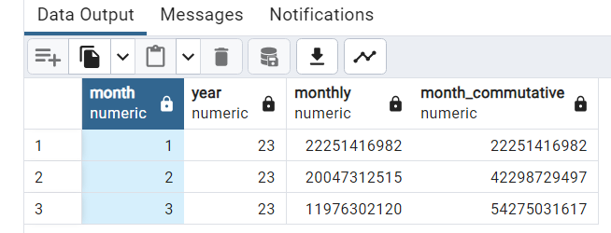

Que2) Most Popular Products/Services:

*select merchant_type from*

*transactions*

*group by merchant_type*

*order by count(*) desc*

*limit 5*

Ans=>

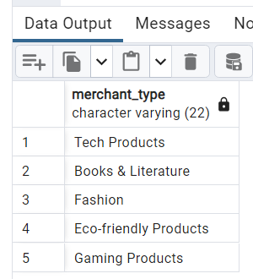

Que4) Average Transaction Amount by Product Category:

select merchant_name,avg(transaction_amount) from

transactions

group by merchant_name

Ans=>

"Tech Time" 498538.433928571429

"Culinary Charms" 496119.314285714286

"Sports Unlimited" 496161.817290552585

"Food Fusion" 495327.983347940403

"Health Hub" 509730.172257479601

"Smart Synergy" 492562.559090909091

"Outdoor Adventures" 497716.352690008540

"Fit Flex" 493210.870845204179

"Smart Solutions" 506419.173371647510

"Artistic Creations" 492658.203058623619

"Book Buffet" 487911.170709793351

"Family Fun Zone" 495290.766151046406

"Artistic Aura" 480536.378983634798

"Wellness World" 483959.781456953642

"Luxury Lounge" 482748.514691943128

"Wellness Hub" 480536.810160427807

"Auto Allure" 526114.636277302944

"Home Decor Hub" 494872.558341369335

"Pet Purrfection" 495364.285201793722

"Luxury Living" 514968.050236966825

"Beauty Bliss" 488357.495745633677

"Gaming Galaxy" 492766.870222222222

"Hobby House" 509192.171818181818

"Fashion Fusion" 492365.982092365693

"Kids Club" 494527.860531309298

"Business Bliss" 495987.294573643411

"Digital Drive" 491480.572097378277

"Beauty Boutique" 486762.902483900644

"Home Harmony" 505018.521043000915

"Fashion Fiesta" 519118.005639097744

"Tech Touch" 506916.469174977335

"Book Nook" 510100.496866606983

"Gourmet Delights" 506673.913162705667

"Digital Delights" 492748.432630614115

"Global Goods" 490605.441696113074

"Fashion Haven" 500643.808231992516

"Beauty Bloom" 504055.363546798030

"Food Haven" 511323.462488129155

"Gaming World" 502019.607279693487

"Eco Essence" 489928.400535236396

"Auto Advantage" 496735.034300791557

"XYZ Electronics" 503540.468895078923

"Outdoor Odyssey" 492556.494773519164

"Fashion Forward" 505611.273488372093

"Outdoor Opulence" 504399.111538461538

"Tech Emporium" 504327.236135957066

"Fit Focus" 506699.443362831858

"Pet Parade" 505564.716730038023

"Auto Care" 505112.155221072437

"Wellness Whiz" 503630.875722543353

"Tech Trends" 497790.314788397527

"Pet Paradise" 506379.233670653174

"Pet Palace" 497460.260185185185

"Smart Living" 493518.105311355311

"Outdoor Oasis" 488836.196078431373

"Book Binge" 503574.596507352941

"Business Bistro" 492048.999103942652

"Home Sweet Home" 483087.270927092709

"Digital Dream" 481781.220264317181

"Eco Emporium" 498447.661668228679

"Digital Dreams" 497695.568380213385

"Gaming Glory" 501429.027777777778

"Kids Kingdom" 507034.045248868778

"Music Galaxy" 516904.500000000000

"Food Fantasy" 506106.682027649770

"Tech Triumph" 508318.435059037239

"Wellness Wonders" 492487.084792626728

"Travel Empower" 508077.052197802198

"Luxury Lane" 497672.349859681946

"Home Hub" 502967.152317880795

"Gaming Gala" 479827.376246600181

"Cosmic Books" 503174.348368522073

"Culinary Carnival" 499269.911131898971

"Artistic Express" 489926.085895117541

"Global Gifts" 492037.439814814815

"Business Buzz" 501113.590440487348

"Health Haven" 480633.042240587695

"Fashion Trends" 499378.133959044369

"Auto Express" 484793.580454096742

"Culinary Creations" 500829.258992805755

"Health Heights" 511143.775342465753

"Fitness Focus" 509525.743879472693

"Hobby Haven" 488479.808461180846

"Health Essentials" 494716.908014571949

"Family Funtime" 490691.494423791822

"Family Fest" 504037.625230202578

"Bookworm Haven" 484411.865820489574

"Foodie Haven" 496538.212673611111

"Kids Corner" 480100.164192949907

"Global Groove" 505312.830798479087

"Smart Style" 491905.400339270568

"Artistic Adventures" 494803.682905225864

"Auto Zone" 520460.616604477612

"Eco Elegance" 488492.826848249027

"Fit & Fab" 501457.735378715244

### Que 5)Transaction Funnel Analysis:

### select transaction_status,count(*)

### from

### (SELECT

### transaction_type,

### CASE

### WHEN (transaction_type='PURCHASE' or transaction_type='CASH_WITHDRAWAL') THEN 'completed'

### WHEN transaction_type='ACCOUNT_VERIFICATION' THEN 'pending'

### ELSE 'cancelled'

### END AS transaction_status

### FROM

### transactions) t1

### group by transaction_status

### order by count(*) desc;

### Ans=>

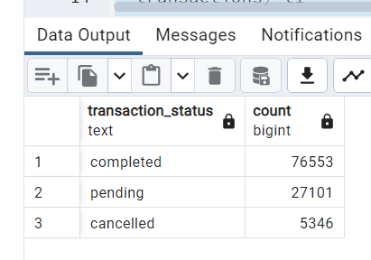

### Que 6) ****Monthly Retention Rate:****

Design a SQL query to calculate the Monthly Retention Rate, grouping users into monthly cohorts.

Ans=> WITH cohorts AS (

-- Determine the first activity month for each user

SELECT

user_id,

DATE_TRUNC('month', MIN(transaction_date)) AS cohort

FROM

transactions

GROUP BY

user_id

),

activity AS (

-- Determine the activity month for each user

SELECT

user_id,

DATE_TRUNC('month', transaction_date) AS activity_month

FROM

transactions

),

monthly_activity AS (

SELECT

c.user_id,

c.cohort,

a.activity_month

FROM

cohorts c

JOIN

activity a ON c.user_id = a.user_id

),

retention AS (

SELECT

cohort,

activity_month,

COUNT(DISTINCT user_id) AS active_users,

LAG(COUNT(DISTINCT user_id)) OVER (PARTITION BY cohort ORDER BY activity_month) AS previous_month_users

FROM

monthly_activity

GROUP BY

cohort,

activity_month

)

SELECT

cohort,

activity_month,

active_users,

previous_month_users,

CASE

WHEN previous_month_users IS NULL THEN NULL

ELSE ROUND((active_users::DECIMAL / previous_month_users) * 100, 2) AS retention_rate

END

FROM

retention

ORDER BY

cohort,

activity_month;